ABC Messaging Application Proposal Report



**Group Members:**

**Hannah Ashna Jacob N0865554 – Leader**

**Stelios Mitas N0836754**

**Mohamed Ali T0084862**

**Allison Costa Amaral N0871194**

Table of Contents

**Introduction3**

Summary3

Aim3

**The Project – Instant Messaging (IM) Applications:** 3

Initial Ideas4

The Team5

**Methodology6**

**Feasibility and Risk Analysis7**

Technical Feasibility7

Economic Feasibility9

Organizational Feasibility10

Feasibility and Risk Analysis Diagram11

**Project Scheduling12**

Project Plan Table12

Gantt Chart Diagram 113

Gantt Chart Diagram 214

**Requirement Capturing Method15**

**Functional Requirements16**

**Non-Functional Requirements17**

**Case Diagram18**

**Class Diagram19**

**Behaviour Sequence Diagram20**

**Database Design21**

Entity Relationship Diagram21

Sample SQL Statements21

**User Interface (UI) Design22**

Main Application22

Dark Mode Version23

User Account Details24

**Individual Reflection and Group Leader Reflection25**

**Appendix26**

Questionnaire Questions and Response26

Interview Questions and Response27

**References28**

**Introduction:**

**Summary of the Project:**

**Aim:**

Firstly, the project aims to create an internal instant messaging app for the ABC Company that would enable it to separate their agent’s personal communications from their work-related communications. In addition to this, the project intends to create an application that contains all the desired features of a mainstream messaging application while simultaneously being able to safely and confidentially store all the data for the company. Subsequently, the final product should be adaptable so that it can be marketed to the ABC Company’s sister companies.

**The Project – Instant Messaging (IM) Applications:**

**Instant Messaging (IM) applications have taken the world by storm since the mid-2000s and their popularity has only grown. Back in 2004, one author** (Flynn, 2004) **made note of how IM is used “by someone in nearly every U.S. Company” and that at the time, “90% of businesses” are already “engaging” with some form of IM application. She also noted that it was “here to stay” and as recent trends show that is in fact true. One article noted that WhatsApp stated that around “75 billion messages” were sent through the application on New Year’s Eve in 2017** (Dow Jones Institutional News, 2018)**.**

**Instant messaging has become a valuable tool in our personal lives, hence, why shouldn’t there be a business model of it for our work lives. Nancy Flynn points out several benefits that instant messaging can have for businesses such as it being a tool for “instant real-time communication”** (Flynn, 2004) **which means it takes away any sort of delays when it comes to decision making. This is especially useful when there are time constraints. Additionally, it promotes “multitasking” and “employee productivity” due to how it’s much easier to send a short text to someone rather than composing a formal e-mail or scheduling a business call. Moreover, it can also cut down costs for the company with regards to long distances and travel as workers don’t have to travel for meetings when they can have all their discussions via the application’s chat box or video/voice call features.**

**Therefore, there is a market for a business-specific instant messaging application. This would allow users to not only separate their business and personal lives but also allow for companies to harness the benefits of the technology to improve their overall productivity and outputs.**

**Initial Ideas:**

**Our primary focus for the IM application project is that we create an instant messaging application that is capable of being used in various companies/scenarios. Hence, its ability to adapt should be a key feature and focus during the development process. Furthermore, we intend on retaining all key features of other popular instant messaging applications such as private and group chats, voice and video calls, etc. The application should also have a web version (I.e. for people to access during meetings on their laptops/tablets rather than having it just on their phones). This makes it easier for people to stay on top of other conversations while in their meetings. Hence, providing users with the option to multitask easily.**

**Subsequently, the application should prompt users for their location upon registration so that it can provide them with access to all the contacts in their main office location. The application then relies on the phone’s location feature to give the user access to other office location’s contacts when the user travels for business. The application should also have a database where it stores all the user accounts and when a new user registers an account the database gets updated and all those who should have access to this new user’s contact get a notification that their contact list has been updated. Lastly, users should only have access to certain contacts within the database and not all. This is to ensure that the office hierarchy system is maintained even online. This will all be determined via the roles assigned to the user upon registration (or whenever it is updated).**

**There are several key factors to consider first before beginning the project:**

* **Firstly, we need to have a**n approximate number of how many users will be using this to gauge the necessary size of the database that will store all the data.
* Furthermore, does the office provide a certain type of phone? or do users use their own phones? This is a vital question to be asked as in the case that they use their owns phones the application needs to be functional on several types of mobile Operating Systems (OS).
* Moreover, as the company intends to maintain the confidentiality of the messages exchanged on the application, how the application carries out its authorisation process is extremely crucial. Should it simply use the user’s work e-mail? Base it off their work e-mails? Or should there be a process to generate an entirely new identification system for users?
* Lastly, should the application make use of cloud synchronization to make the backing up of data practically instantaneous?

**These factors influence how the application will be built and/or how it will function. Hence, a clear understanding of them needs to be present to proceed, otherwise, this could cause problems in the later stages of the application's development.**

**The Team:**

It comprises of 4 members:

* Hannah Ashna Jacob is the project manager and will oversee all decisions and actions made concerning the project. She will also take on the role of a Business Analyst and ensure that all the customer’s needs/requirements are met through the development phase.
* Allison Costa Amaral is the User Interface (UI) Designer for the application and is responsible for the visual design of the application, in addition to, ensuring that the user’s experience while using the application is held to the highest standards.
* Mohamed Ali is the Lead Developer for the application, and his focus is the developmental phase. He oversees all the programming and design elements relating to the structure and functionality of the actual application.
* Stelios Mitas is the Supporting Developer and is primarily responsible for aiding the lead developer in creating cross-platform versions of the application.

**Methodology:**

In order to decide which methodology was the most appropriate, the team decided to compare different types of methodologies against each other.

While looking into the use of the waterfall methodology the team quickly realised that it would not be an ideal choice for this project. This is primarily due to there being little room for errors. With the waterfall method, developers don’t have the time to come back and discuss their progress with the implementation of new features which means a full review of the application’s functionality can only be done once the project is complete. This can result in the entire project being delayed if the final product is not up to standard especially if it’s due to a feature that was implemented in the early stages of development. This issue can be prevented by the Agile methodology’s scrum feature.

As defined by one researcher, the Agile methodology comprises of work being “broken down” into “short”, “regular and frequent cycles” (Antlova, 2014). This makes it much easier to focus on specific areas of a project and ensure that each component of the application is of the highest quality possible. With regards to this project’s instant messaging app, all its features must be to the client’s requirements. Furthermore, the project makes use of the Scrum process. The research paper (Antlova, 2014) likens it to a rugby scrum wherein a rugby game is “relaunched” after a “short-pause”. This short pause allows the team to showcase their work to the client and receive their feedback on it before moving on to the next task. Hence, preventing the team from spearheading through the entire project without any appropriate feedback and ending up with a product that the client does not want.

Moreover, if the team decided to use the waterfall method as (Jin-hang Liu, 2014) points out, the methodology does not enable an “effective” and “feasible” pattern of communication between the client and developers like the Agile methodology does. This in turn means that the project may diverge from the client’s vision during the development phase. On such a project, especially since the owner intends on marketing it to other companies, it’s important to get client input at every possible stage. Hence, the Agile methodology is more favourable.

One weakness may be that the waterfall method is faster than the agile methodology, however, the agile methodology focuses on a rapid delivery wherein as a by-product of testing and modifications being done throughout the sprints the team can deliver a completed product at a much faster. In comparison the only focusing on finishing a product, testing it and then having to revisit the entire development phase again.

In conclusion, the team have therefore decided that the agile-scrum methodology is the most suitable for this project.

**Feasibility and Risk Analysis:**

**Technical Feasibility:**

Functional Area:

|  |  |
| --- | --- |
| Risk Description | Since the company is primarily a book company, they may not have a strong IT department that can do a project of this size. |
| Severity (Low/Medium/High) | Medium |
| Potential Impact | The application is not up to par with the company owner’s requirements. |
| Ways to mitigate | A hire an experienced development team. |

Technology:

|  |  |
| --- | --- |
| Risk Description | Messaging App technology is popular and well known currently on a global scale, hence an experienced development team would be capable of managing it. |
| Severity (Low/Medium/High) | Low |
| Potential Impact | Being unfamiliar with the technology could lead to problems arising in the development phase of the application as the team may not fully understand how certain things work and hence, incorrectly construct things. |
| Ways to mitigate | Have a familiarisation process before beginning the developmental phase to ensure that all team members are on the same page with their proficiency in the technology. |

Project Size:

|  |  |
| --- | --- |
| Risk Description | The project is relatively large scale due to the nature of the company it is being designed for. |
| Severity (Low/Medium/High) | High |
| Potential Impact | Mismanagement of resources or project tasks may occur as with a large project size it can be difficult to keep track of everything at the same time. |
| Ways to mitigate | Properly plan out the project’s stages and keep all team members within a regularly updated communications loop. |

Compatibility:

|  |  |
| --- | --- |
| Risk Description | The company has been using an alternative instant messaging app, hence there’ll have to be a period allocated for the transition of user conversations/groups from the old app to the new internal application. The workers will have to switch back and forth the old app and the new app to access old messages for the first few weeks/months. |
| Severity (Low/Medium/High) | Low |
| Potential Impact | This is only a temporary problem that’ll take place over the transition period. However, may result in users becoming frustrated over having to manoeuvre between two applications for that time. |
| Ways to mitigate | Have users use the old apps and the new apps for a few weeks until they’re able to solely rely on conversations made via the new internal application. |

**Economic Feasibility:**

Tangible Costs and Benefits:

|  |  |
| --- | --- |
| Risk Description | The company may invest a lot of money into the development of the app, however, if the application fails to be developed up to the owner’s requirements within the designated period this could lead to the company spending more money and time on it. |
| Severity (Low/Medium/High) | Medium |
| Potential Impact | Depending on how much money is being invested in this project it could severely impact the company’s finances. |
| Ways to mitigate | Make a proper financial plan for project spending. |

Intangible Costs and Benefits:

|  |  |
| --- | --- |
| Risk Description | A failure or major product error occurring with the application when it has already been distributed to other companies for use as intended by the ABC company owner |
| Severity (Low/Medium/High) | Medium |
| Potential Impact | This could lead to the perception of the ABC company becoming skewed and them being viewed as unreliable due to their failure with the product. |
| Ways to mitigate | Ensure that the application has been trialled for several months and is optimal before beginning the business venture to share the application with other companies. |

**Organisational Feasibility:**

Strategic Alignment:

|  |  |
| --- | --- |
| Risk Description | The company’s use of the application may shift over time depending on how the economy evolves and how the company responds to it. Hence, rendering certain features of the application later redundant. |
| Severity (Low/Medium/High) | Low |
| Potential Impact | Developers may have spent time focusing on that now redundant feature when they could have instead used the time to develop another necessary feature. |
| Ways to mitigate | Ensure that the application is constantly being updated and revised so that it suits the needs of the company. |

User’s Acceptance:

|  |  |
| --- | --- |
| Risk Description | Some users may not be proficient with the technology so may take a longer time to get used to it and be able to make use of all the application’s features. |
| Severity (Low/Medium/High) | Medium |
| Potential Impact | When users are not able to understand the system, they are not going to work properly and have the best results in their job so the organisation might notice a decline in productivity. |
| Ways to mitigate | Create a more user-friendly User Interface based on questionnaires and suggestions that users applied. In addition to this, the development team should host an introductory session to the application which teaches staff members how to properly use the app. |

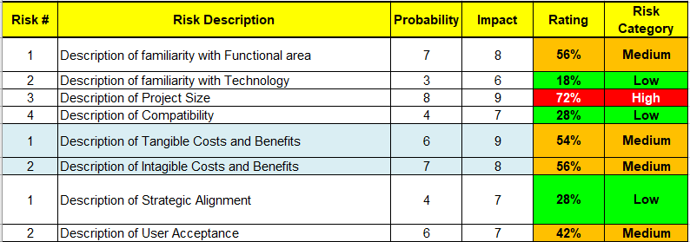

**Project Scheduling:**

|  |  |  |
| --- | --- | --- |
|  | Task Name | Duration |
|  | **Planning and Analysis Phase** | **20** |
| 1 | Identify Key Stakeholders | 5 |
| 2 | Form Project Team | 5 |
| 3 | User Story Workshop | 5 |
| 4 | Finalise requirements | 5 |
|  |  |  |
|  | **Sprint 1 – Feature Designing** | **20** |
| 5 | Design interface features | 5 |
| 6 | Develop pseudocode for features | 7 |
| 7 | Demo to the User | 2 |
| 8 | Retrospective + Make the appropriate changes | 6 |
|  |  |  |
|  | **Sprint 2 – User Interface Design** | **20** |
| 9 | Planning + Design | 5 |
| 10 | Develop potential templates to showcase | 7 |
| 11 | Demo to the User | 2 |
| 12 | Retrospective + Make the appropriate changes | 6 |
|  |  |  |
|  | **Sprint 3 – Instant Messaging System Implementation** | **20** |
| 13 | Writing the code for a basic system using the outline made in Sprint 1 | 10 |
| 14 | Demo to the User | 4 |
| 15 | Retrospective + Make the appropriate changes | 6 |

|  |  |  |
| --- | --- | --- |
|  | Task Name | Duration |
|  | **Sprint 4 – Additional Features Design** | **20** |
| 16 | Design interface features | 5 |
| 17 | Develop pseudocode for features | 7 |
| 18 | Demo to the User | 2 |
| 19 | Retrospective + Make the appropriate changes | 6 |
|  |  |  |
|  | **Sprint 5 – Implementation of New Features** | **20** |
| 20 | Writing the code for the new features using the outline made in Sprint 4 | 10 |
| 21 | Demo to the User | 4 |
| 22 | Retrospective + Make the appropriate changes | 6 |
|  |  |  |
|  | **Sprint 6 – Testing Phase** | **10** |
| 23 | Test all features of the application | 5 |
| 24 | Retrospective + Make the appropriate changes | 5 |
|  |  |  |
|  | **User Acceptance Phase** | **15** |
| 25 | Present final product to User and showcase all features | 5 |
| 26 | Retrospective + Make the appropriate changes | 5 |
| 27 | Final Demo | 2 |
| 28 | Release Product | 3 |

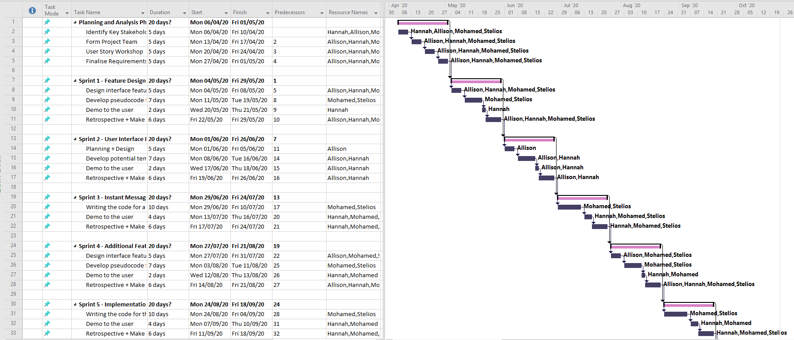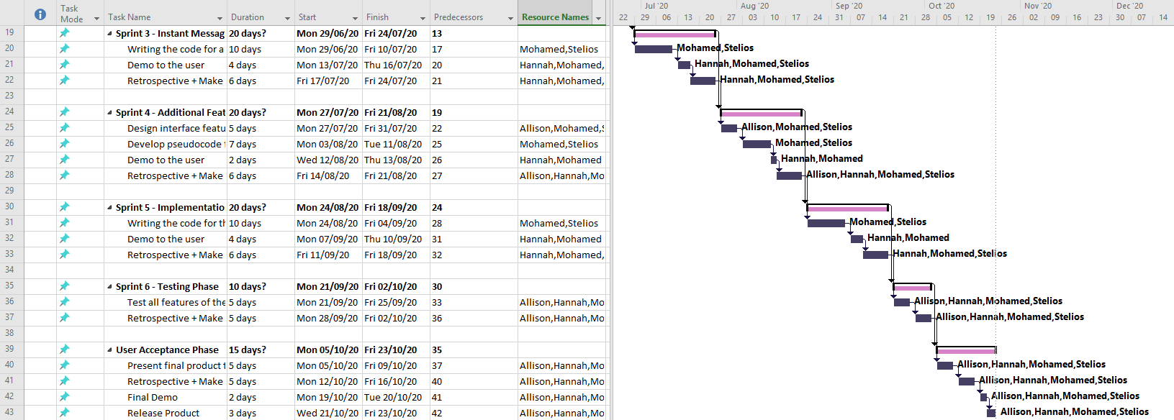

**Requirement capturing method:**

In order to capture requirements, our team decided to use two techniques. A questionnaire for employees to get to understand what features of the current messaging app that they are using is important to what and why. In addition to this, we decided to use a questionnaire on employees over other techniques as it is so much easier to deploy an online questionnaire via e-mail to thousands of employees within a multinational company. This would then ensure that we received the highest possible number of responses and thus ensuring that we had a holistic understanding of the employee’s needs and wants with regards to this application.

Subsequently, we decided to have an interview with the company owner to get a full understanding of his intentions with how the app was to function and of how it would later be marketed to other companies. We decided to conduct an interview as we would be able to get a much more detailed understanding of his requirements and we’d also be able to interact with him and probe him further if we’re unsure about some of his responses.

A sample of our questionnaire and interview questions is attached in the Appendix in addition to responses from a staff member and the company owner.

**Functional Requirements:**

**Process:**

* Users must be able to send, receive and view messages
* Users are assigned roles when they join the application
  + Roles based on their current position in the office
  + Should be updated by the Admin team if there is a change
* Whenever a new message is received, users should be notified of this
  + Either via notification bar or through a notification sound
* The application should use user location to provide a user with local office contacts in addition to their base-office contacts
  + This is extremely useful for users that travel for work and need to communicate with local offices
* A status option so that users can inform others whether they are available to chat/have a call
  + When in meetings, users can put themselves on “do-not-disturb” mode
* Ability to send all kinds of multimedia
* Voice and video calls
* A user profile that has their picture, title and primary office location as well as their current status in case other users want to know who they are
* Those with the group leader role can create and manage their own groups
  + They cannot see other group leader’s groups
* Administration team has unrestricted access to all groups and conversations
* The application should have a light and dark mode
  + Certain users have certain preferences

**Information:**

* All messages must be stored in the company’s servers that are dedicated to the internal instant messaging application
  + Each message must be stored with the following details: The ID of the user that sent it, the time in which it was sent and where the message was sent (ID of the other user or the group ID)
* Each user’s details should be stored too
  + This includes their personal ID they use to log in, their name, the role that they were assigned as well as their contact number and e-mail address

**Non-Functional Requirements:**

**Operational:**

* The application should run on both iOS and Android devices as well as have a Web-version to be used on laptops and desktops
  + The web application should be compatible with all browsers as user preferences may differ and the application should be able to cater to this

**Performance:**

* Messages are to be sent and received within 5-10 seconds
* Messages must be stored on the server as soon as they have been sent out
* Messages should come with sent and read receipts
  + A user should be able to see who has received their message and who has read it
* The application must be constantly available
  + It being offline at any point of time is not feasible as this could cause major disruption within the company’s daily routine

**Accessibility:**

* The application should have the option to switch between a light-mode and a dark-mode as certain users may find the light-mode to be too overwhelming to look at repeatedly throughout the day

**Security:**

* All messages must be encrypted, especially once stored in the company’s servers
  + Only the administration team have access to the decryption keys
* An authorisation process must precede a user getting access to their chats
  + They must ensure that they enter their ID and password correctly first
  + A user’s ID and password combination is issued to them in less than a week of them joining the company
  + If the user forgets their passport, they have the option to click forgot password and the admin team must have a system in place to reset it instantaneously

**Cultural:**

* The application should have several language options
  + At the very least language options based on wherever the company has offices

**Political:**

* Ensure that the application adheres to all local (and international) privacy laws
  + i.e. The EU - The General Data Protection Regulation (GDPR)

**Case Diagram:**

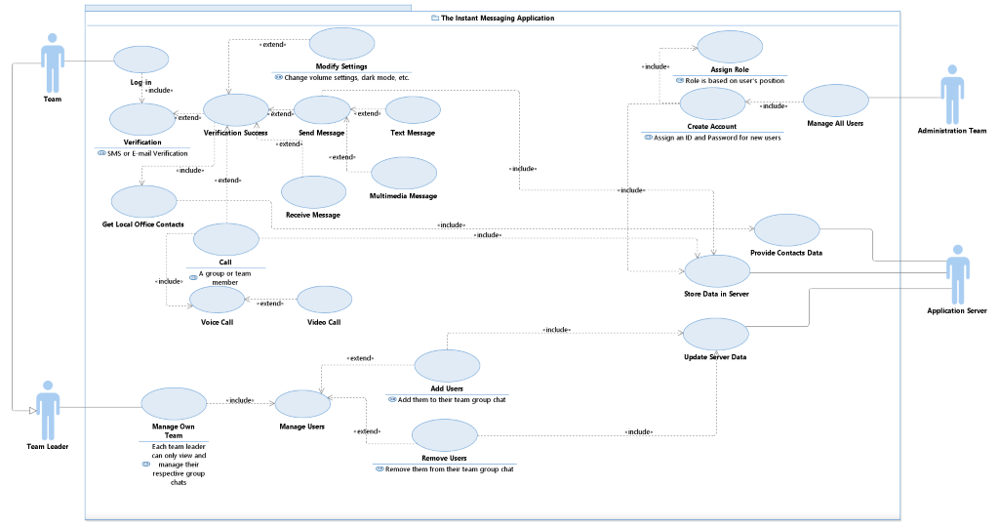

**Class Diagram:**

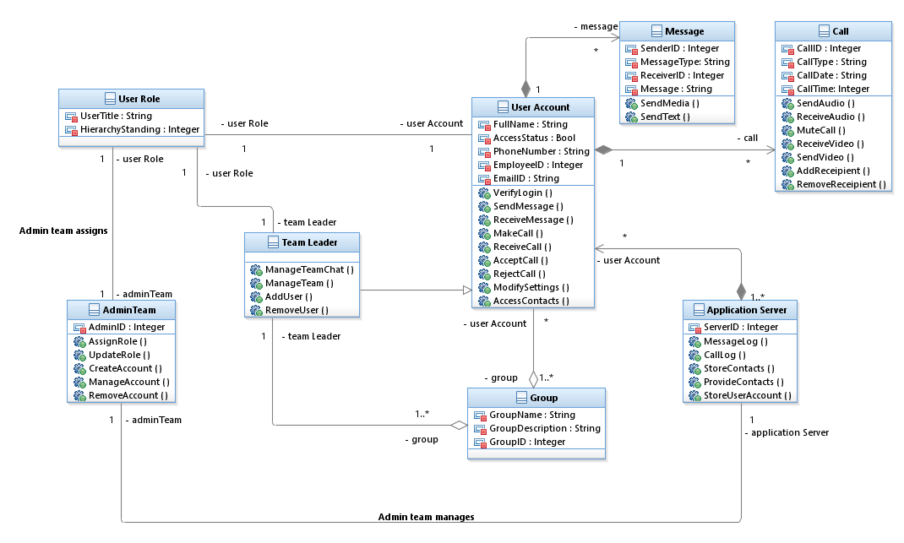The class diagram’s main class is the user account class as this is class dictates how the rest of the application can function. There is also a specific class for the team leader as despite it inheriting everything from the user account, the team leader is given have extra methods that they’ll be able to use. The admin team class’s primary purpose is to manage the user role class and the application server class as they’ll oversee the maintenance of the application and the monitoring of all message/call logs. The group, message and call classes provide the functionality to the application as it allows the users to send and receive messages and calls while team leaders can create group chats for their teams.

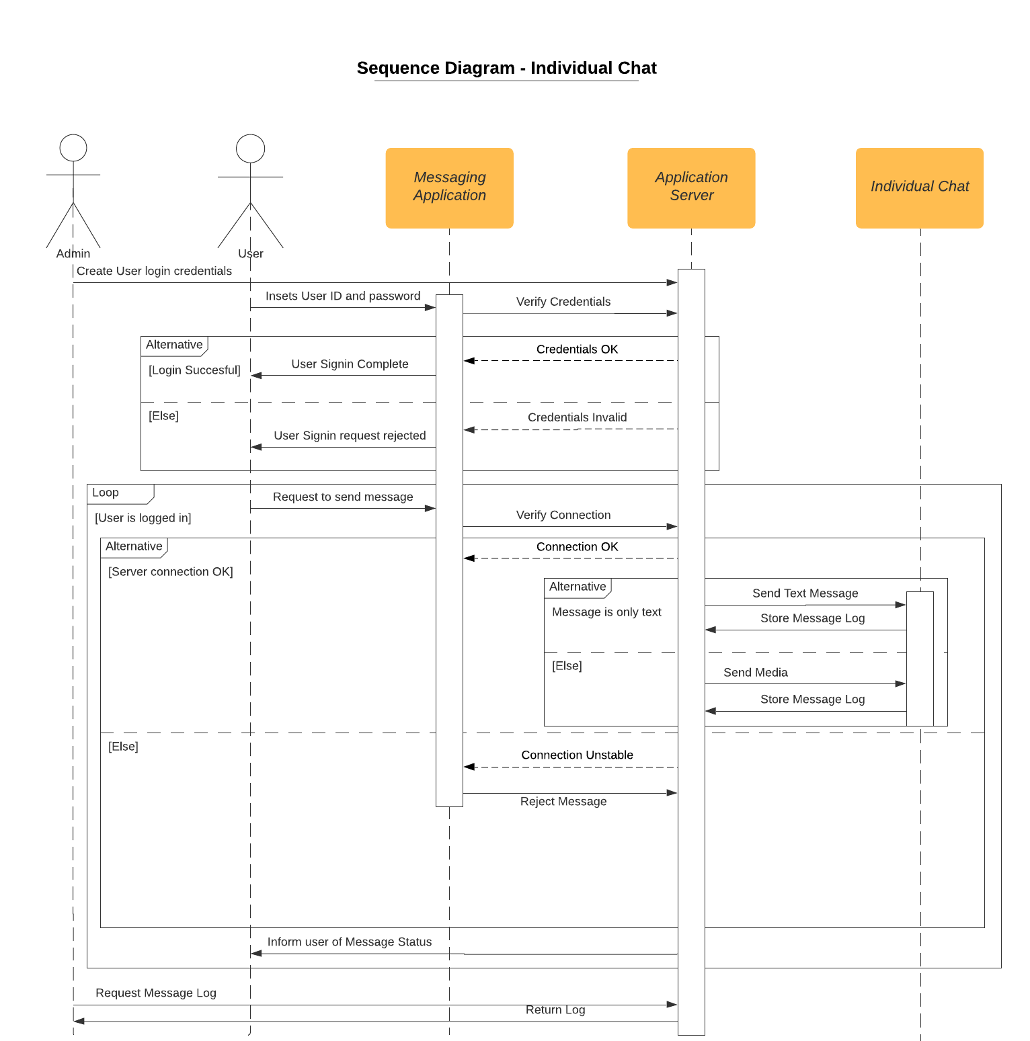**Sequence Diagram:**

The diagram considers the sequence of events that would transpire when a user’s tries to send a message (text/media) to an individual chat on the application. First of all, their account is created by the admin team. The user then attempts to log into their account on the application using the credentials they were assigned. Here, depending on whether their combination is correct they are granted or denied access to their account. In the case they’ve been granted access they are now able to send a message via the application. The server checks if their connection is stable, if it is the message gets sent. The message log details are stored in the server. These details can later be accessed by the Admin team via the server. The same sequence of events applies to a group-chat instead of an individual chat.

**Entity-Relationship Diagram (ERD):**

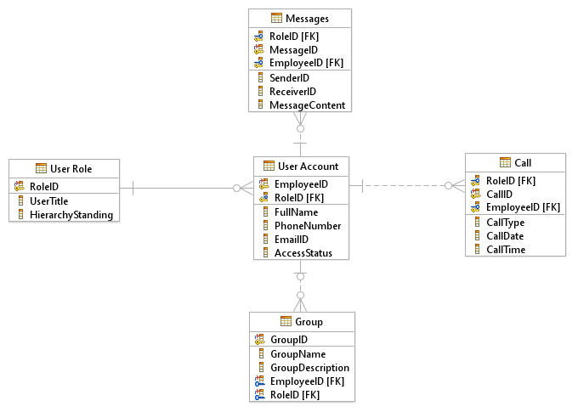

**User Interface (UI) Design:**

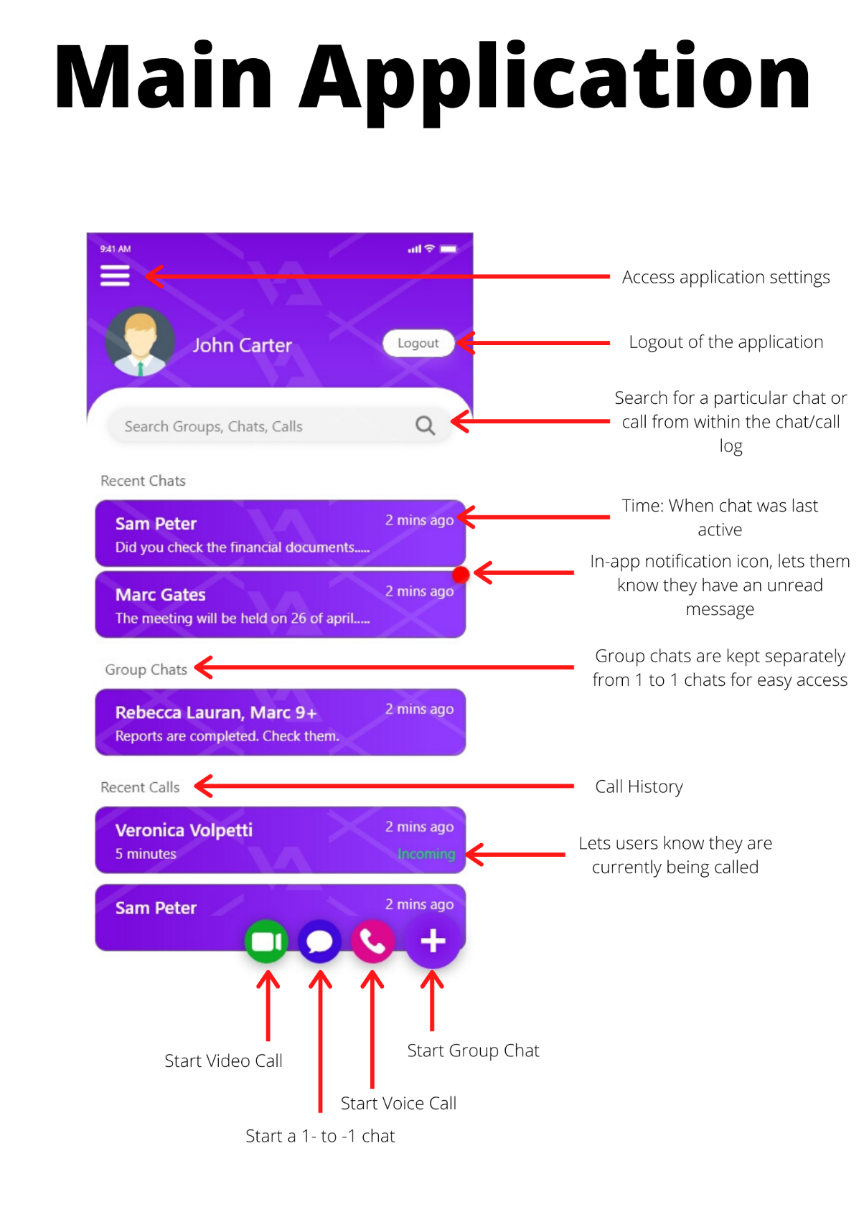

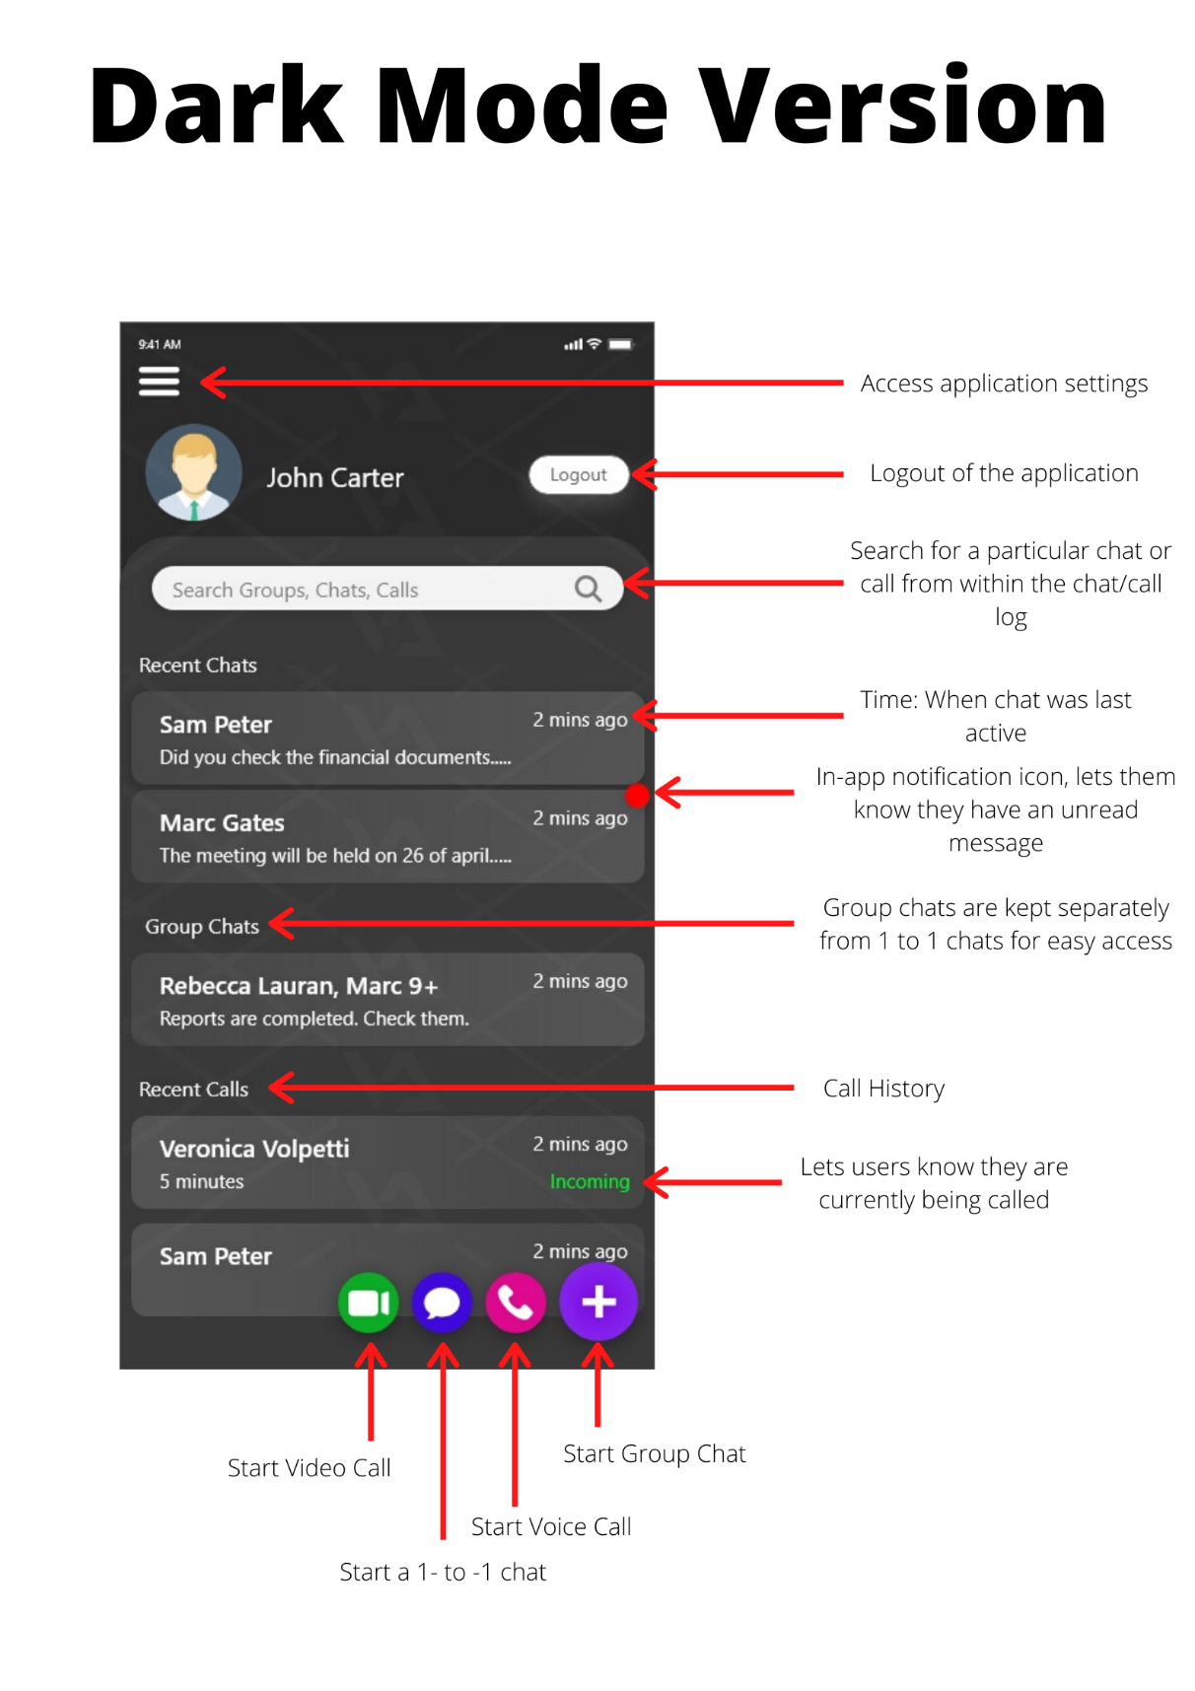

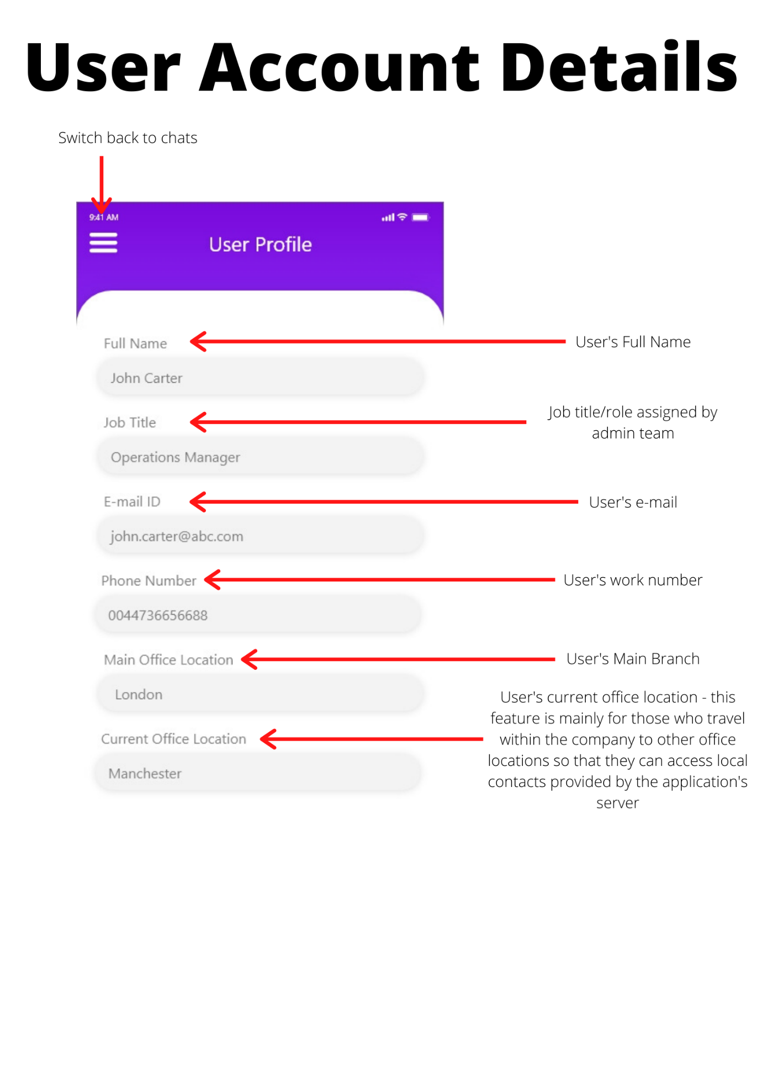

**Individual Reflection:**

**Hannah (N0865554) – Group Leader:**

**Reflection as Group Leader:** As group leader I decided it was best if we worked according to everyone’s strengths and assigned appropriate tasks for everyone. For the initial portion of the project all of us worked together in coming up with our main idea, we would meetup and have brainstorming sessions before we settled on a plan.

Once we decided on our course of action, we would have weekly mid-week meetups to review our progress on the project and for me to designate tasks to the other group members. Since my group has a lot of international students whose first language is not English, I took up the role of the scribe, wherein my team members would send me their research or work and I would review it, edit it and then update our online document. This method worked quite well for us; however, Mohamed began to stop showing up to meetings after our first 3 weeks of meetings. He would often skip seminar session meetings too without informing the group. When I attempted to contact him via e-mail and via our Microsoft teams’ group chat, he would never respond. Hence, the project was primarily done by me, Allison and Stelios. I had assigned Mohamed with the task of handling technical feasibility in the risk analysis section and it took him over a month to complete half of it despite me pushing for him to do so in-person and via e-mail. Therefore, his primary contribution for the project is in the User Interface design.

Stelios, Allison and I attended every meeting that the group held, and we would spend most of it reviewing diagrams and our other written sections. Admittedly, they struggled with understanding how a lot of the diagrams worked initially, so we would brainstorm them together and then I would use our sketches and make the actual diagrams.

**Personal Reflection:** I was elected to be group leader hence a large portion of the group’s management and coordination was handled by me. I had to ensure that all group members knew what they were doing and what had to be done as well as review the work that they had submitted. Throughout the project I often struggled with a heavy workload as one member was rarely present and the other two struggled to understand a lot of the concepts being thought on the module.

I would often spend a lot of my time working on the project, re-writing paragraphs or doing the research on my own. The work of Stelios and Allison was certainly helpful; however, I believe their contributions to the group could have also been a lot higher as I feel a majority of this project has been done by me due to the amount of work I had to put into it.

**Appendix:**

**Questionnaire:**

1. What feature of the current instant messaging (IM) app is the most important to you?
   1. Why? (Optional Elaboration)
2. On a scale of 1 (Low) to 10 (High) how would you rank the application with regards to its importance in you being able to work effectively?
3. Is the ability to separate your group chats from your 1-to-1 chats an important feature?
   1. Why? (Optional Elaboration)
4. Do you require voice/video calls?
   1. How important is this feature to you on a scale of 1 (Low) to 10 (High)?
   2. Approximately, how many users would you ideally like to have on one group call at the same time?
5. Do you require the ability to switch between a light-mode and dark-mode version of the application?
   1. How important is this feature to you on a scale of 1 (Low) to 10 (High)?
   2. Why? (Optional Elaboration)
6. Do you think a desktop version for the application would be ideal?
   1. How important is this feature to you on a scale of 1 (Low) to 10 (High)?
   2. Why? (Optional Elaboration)
7. Do you think encryption of all messages should be a priority?
   1. How important is this feature to you on a scale of 1 (Low) to 10 (High)?
   2. Why? (Optional Elaboration)
8. Do you agree with your conversations and call logs being stored on a server run and managed by the company’s admin team for legal, safety and administrative reasons?
   1. Why? (Optional Elaboration)

**Questionnaire Response:**

1. The ability to create group chats and a private chat with my co-workers.
   1. This allows me to get a much quicker/on-the-go response from them in comparison to sending out an e-mail
2. Rank: 8
3. Yes, it is an important feature
   1. It helps make the application a little less crowded especially when I have several different types of chats running at the same time. It helps me keep organised.
4. Yes, I do require it
   1. Rank: 9
   2. I would say a maximum of 4 on a video and voice call
5. It is not a necessity but a useful feature
   1. Rank: 6
   2. I don’t need it, but I do know certain co-workers with visual impairments who may find the feature more important.
6. Yes.
   1. Rank: 9
   2. This will allow me to keep on top of on-going conversations while on my laptop at meetings to ensure that I’m not missing out on important tasks/information.
7. Yes.
   1. Rank: 8
   2. I think it’s important to have all our messages protected especially in this digital age where we are at a much higher risk of being hacked or breached.
8. Yes, I do.
   1. I understand that it is important for the company to be able to monitor all ongoing conversations to ensure that everyone is well protected.

**Interview:**

1. How many offices do you have globally?
   1. Approximately, how many staff members do you have employed in total?
2. How would you like users to be able to access their accounts on this application?
3. Do you provide users with a company phone or are users expected to use their own?
   1. What OS does it use?
4. How much control would you like the administration team to have over the application?
5. Do you already have a pre-existing server for the company? Or do we need to invest?
   1. What kind of information would you like to have stored within the server?
6. Aesthetically, how would you like the application to look?
   1. Any colour schemes?
   2. Would you like it to have the company logo or a logo of its own to make it more marketable later?
   3. Should staff have control over their profile pictures, or should the admin team set that up with their company ID photograph when creating their account?
7. Do you have a timeline in mind for when we develop, test and trial this application?
   1. How soon do you plan to sell the product to other companies after its implementation within your own company?

**Interview Response:**

1. We have 5 offices placed throughout the country, our main hub being the one in London.
   1. I have approximately 5000 employees currently.
2. I think users should be assigned with a username and a password by the administration team to avoid the possibility of their office e-mails being compromised in the case that the IM application servers are breached.
3. Yes, we do provide all staff with a company phone.
   1. It uses an Android OS; however, I would like for the application to be catered to all operating systems so that it becomes more marketable.
4. I want them to be able to monitor all conversations and to be able to modify any group settings and user roles. This is so that in case of any security/legal matter I have staff capable of accessing the necessary information immediately.
5. We do; however, those are to store our confidential company and customer data. I think it would be best to invest in a separate server as it would be much better to have a dedicated server for the app, especially for security reasons.
   1. I would like to have all call and chat logs stored on that server so that they can be accessed at any point in time along with the details of the users that come with those logs.
6. I would like for the application to not be too different from standard messaging apps, however, it should have its unique look to it.
   1. Perhaps a purple/white colour scheme or something along those lines
   2. I think the app should have its own logo so we can market it to other companies later, however, should have the option to change the logo via the admin panel to the company’s logo.
   3. Staff’s profile pictures should be handled by the admin team. It would be much more professional to have their staff ID photos as their app photos as well. Especially since this app is primarily for work use.
7. I would like for the development phase to be done at least within a year if not lesser. So that we can have 6months of testing and trials.
   1. I would recommend waiting after a whole year of the application being adopted as our main IM app before beginning our sales pitch to other companies. This is just so we have time to work out any major problems with it. This is to also to protect our company’s reputation.

# References

Antlova, K., 2014. *Agile approach in the project management of the Czech companies,* Czech Republic: Elsevier Ltd..

Dow Jones Institutional News, 2018. *Data Show WhatsApp's Popularity in India -- Market Talk,* New York: Dow Jones & Company Inc.

Flynn, N., 2004. *Instant Messaging Rules.* s.l.:Amacom.

Jin-hang Liu, H.-x. X. H.-b. Z., 2014. *A research into the UML Legend in the Waterfall Model Development,* s.l.: Trans Tech Publications.